Matthew R. Christensen
CS 312 (001) – Dr Martinez, Tony R
April 8, 2021
Branch and Bound Traveling Salesperson Algorithm Report
Screenshots
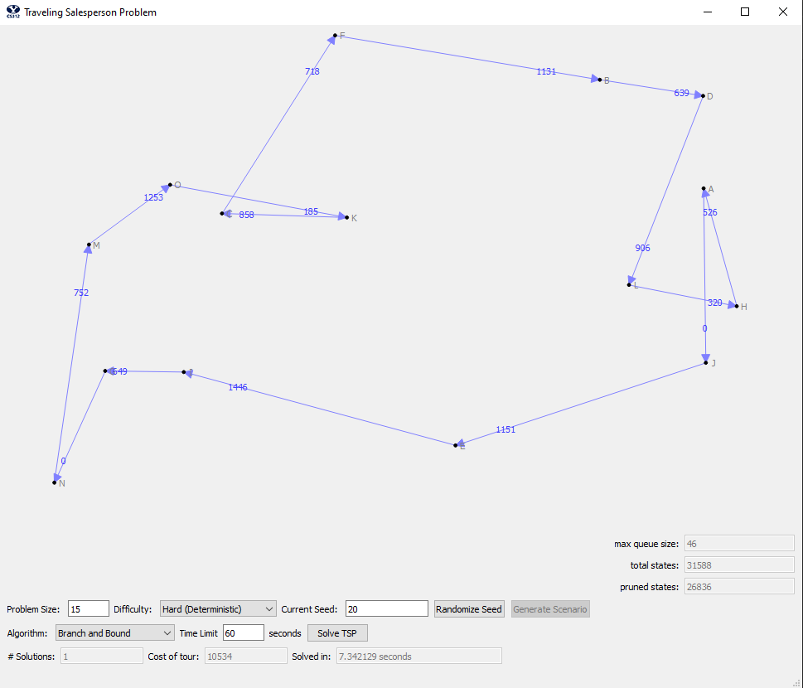
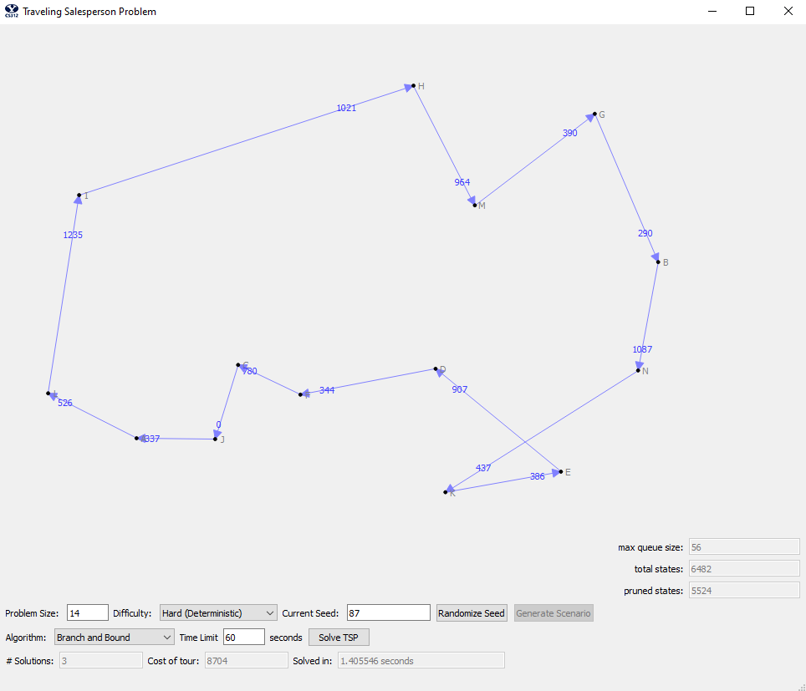
Time and Space Complexity Analysis
First, we will talk about the time and space complexity of our branch and bound traveling salesperson algorithm. This analysis will look at simplified pseudo code that is every similar to the actual algorithm implementation. However, for more details and granularity, please refer to the actual code in the appendix of this paper
This section of the paper will cover the 2nd part of the report ([10] Explain both the time and space complexity of your algorithm by showing and summing up the complexity of each subsection of your code.) as well as some additional description elements of parts 3 and 4 respectively ([5] Describe the data structures you use to represent the states, [5] Describe the priority queue data structure you use and how it works). Additionally, we talk about the 8th section of the report ([10] Discuss the mechanisms you tried and how effective they were in getting the state space search to dig deeper and find more solutions early) in this section of the paper as well.
First is an analysis of the priority queue. For this data structure I chose to use a heap from the heapq python library. Thus, the implementation of our heap is a binary heap, with a push and pop time complexity of O(log n) – the source code can be found here: https://github.com/python/cpython/blob/3.8/Lib/heapq.py. This is accomplished by having a sorted array where the order of said items is maintained whenever adding or removing items (aka, push and pop) – through shifting the tree structure within the array. Because of the ordering of the array, lookups remain a trivially fast operation, which is nicely stated in the documentation, “A nice feature of this sort is that you can efficiently insert new items while the sort is going on, provided that the inserted items are not "better" than the last 0'th element you extracted. This is especially useful in simulation contexts, where the tree holds all incoming events, and the "win" condition means the smallest scheduled time.
The space complexity is a little more involved, because each state we generate will have a size of O(n^2), thus our space complexity scale with the number of state necessary to solve the path. If we let p represent the depth at which we consider, we will have a total space complexity of n/k ∑ n^(2i) | i = 1, and the summation is from i to p.
Next is the complexity of the search state data structure. I created a custom search state class that holds all the necessary state space for each level of search, with function for comparison, initializing the cost matrix, storing the cost matrix, checking to see if a city is in the route, getting the length of the route, reducing the cost matrix, and updating the cost matrix. Additionally, it may be worth explaining that the cost matrix an n by n matrix that holds the cost of travel from one city to another in an array (which is where our space complexity came from in the last section). In all, this class is used to represent the state of a given search route, and this store a reduced cost matrix, the current route, the current cost (or bound) of the route, and the depth of the tree, with means of comparison with the less than operator.
The time and space complexity of each piece of the state class are as follow:
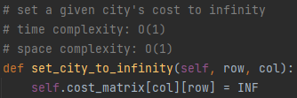
This simple helper function is of constant time for both time and space complexity.
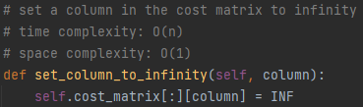
This simple helper function is also of constant time for space complexity (as we don’t need to store anything and we are just modifying the array that has already been stored), while time complexity is O(n), as a whole column is assigned the value of infinity.
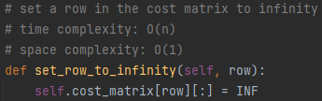
Identical to the last, this simple helper function is also of constant time for space complexity (as we don’t need to store anything and we are just modifying the array that has already been stored), while time complexity is O(n), as a whole row is assigned the value of infinity.
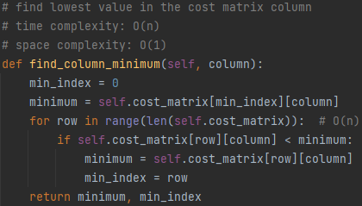
We must iterate through the whole column to find the minimum value, and thus we have a time complexity of O(n). Additionally, the space complexity is constant because we only store 2 insignificant values (the minimum found and its index).
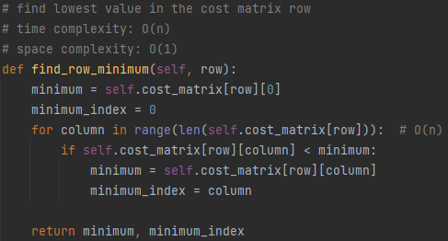
Identical to the last function, in this helper function we must iterate through the whole column to find the minimum value, and thus we have a time complexity of O(n). Additionally, the space complexity is constant because we only store 2 insignificant values (the minimum found and its index).
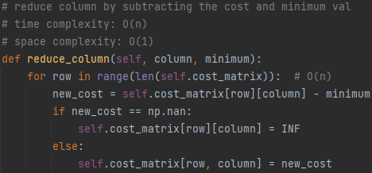
For time complexity, we must iterate through the whole column to reduce it, and thus will have a complexity of O(n). Meanwhile, the space complexity is constant because we do not store anything (just modify the matrix/array that has already been created.
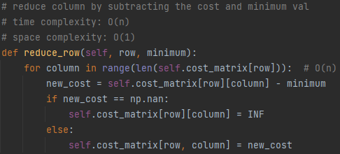
Identical to the last function, this helper function, that reduces the row, must iterate through the whole column to reduce it – and thus will have a time complexity of O(n). Meanwhile, the space complexity is constant because we do not store anything (just modify the matrix/array that has already been created.
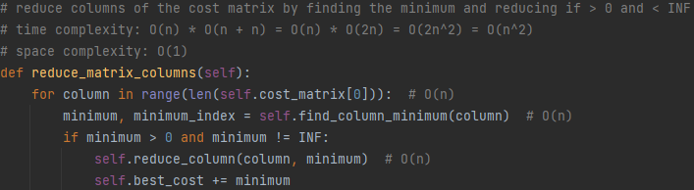
This simple function simply acts as the driver for the reduction of the columns within the cost matrix/array and contains said logic. This the loop of O(n), in the worst case scenario will have a work load of O(n + n), or O(2n) – which is equivalent to O(n). Thus, the overall time complexity is O(n) * O(n) = O(n^2) – (as seen above). Additionally, the space complexity remains constant, because we are simply modifying the data that is already there.
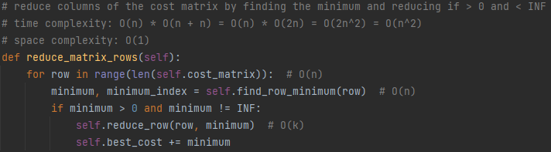
Identical to the last function, this simple helper simply acts as the driver for the reduction of the rows within the cost matrix/array and contains said logic. This the loop of O(n), in the worst case scenario will have a work load of O(n + n), or O(2n) – which is equivalent to O(n). Thus, the overall time complexity is O(n) * O(n) = O(n^2) – (as seen above). Additionally, the space complexity remains constant, because we are simply modifying the data that is already there.
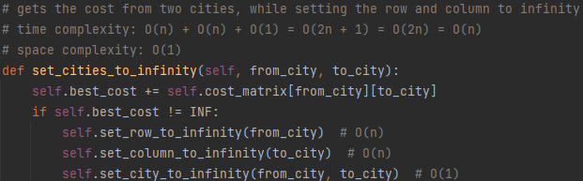
Once again, this simple function acts as a driver to call the previously discussed function, and thus we can simply add the complexity of the functions together for a time complexity of: O(row_inf) + O(col_inf) + O(city_inf) = O(n) + O(n) + O(1) = O(2n + 1) = O(2n) = O(n)
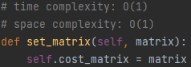
This function is pretty self-explanatory and operates in constant time in both space and time complexities.
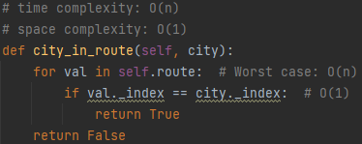
This function, in the worst-case scenario (either the city is the last in the list, or not in the list) will have to iterate through the entire route – which at most will be of n length. Thus we have a time complexity of O(n), while the space complexity remains constant because we are only traversing existing data (not creating new memory).
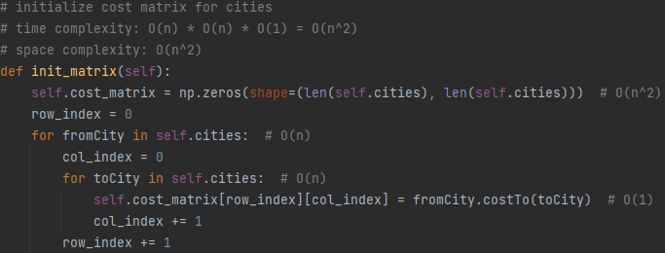
This function initializes the cost matrix array, and thus will have to traves and newly created n by n array, and thus will have a time and space complexity of O(n^2)
This concludes the discussion on the search state class.
Next is the discussion revolving around generating a first solution to beat, known from here on forward as BSSF (best-solution-so-far). The generate the first initial BSSF we use a greedy algorithm:
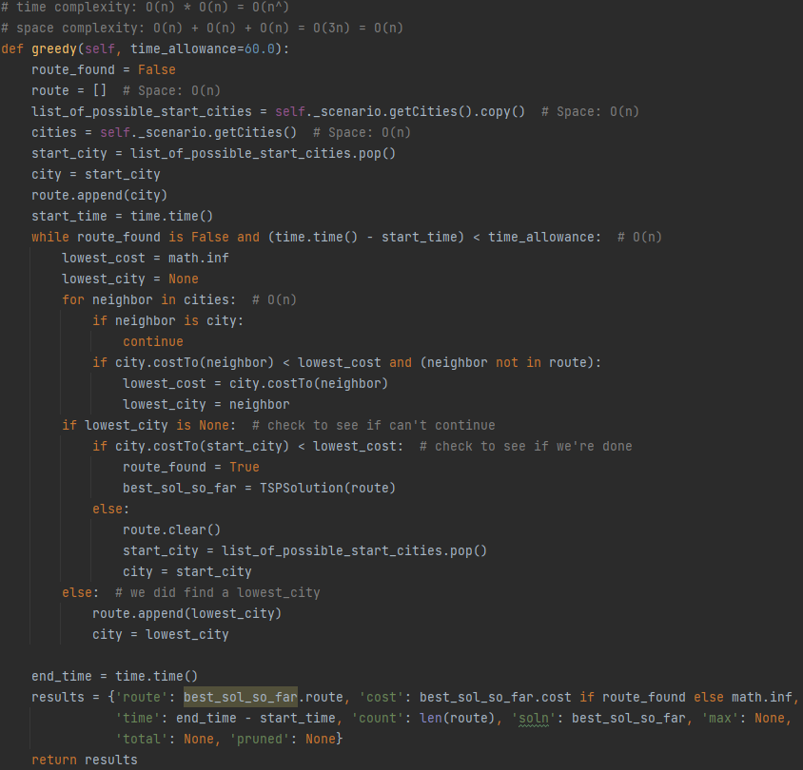
This algorithm simply makes the next best choice by comparing a given city and making the best next choice until finding a complete route. In the worst-case scenario, our while loop will run through all the cities while the worst-case scenario on the inner-loop (i.e., the work on each iteration) is O(n) time complexity as we need to loop through all the neighbors. Thus, our time complexity is O(n) * O(n) = O(n^2). Our space complexity is a little more simple, as we store the route, list of possible start cities, and the list of all cities. Each of these lists are of n length, and thus our space complexity is as follows: O(route) + O(len(cites)) + O(len(cities)) = O(n) + O(n) + O(n) = O(3n) = O(n).
Next, and finally, is the entire Branch and bound algorithm all together:
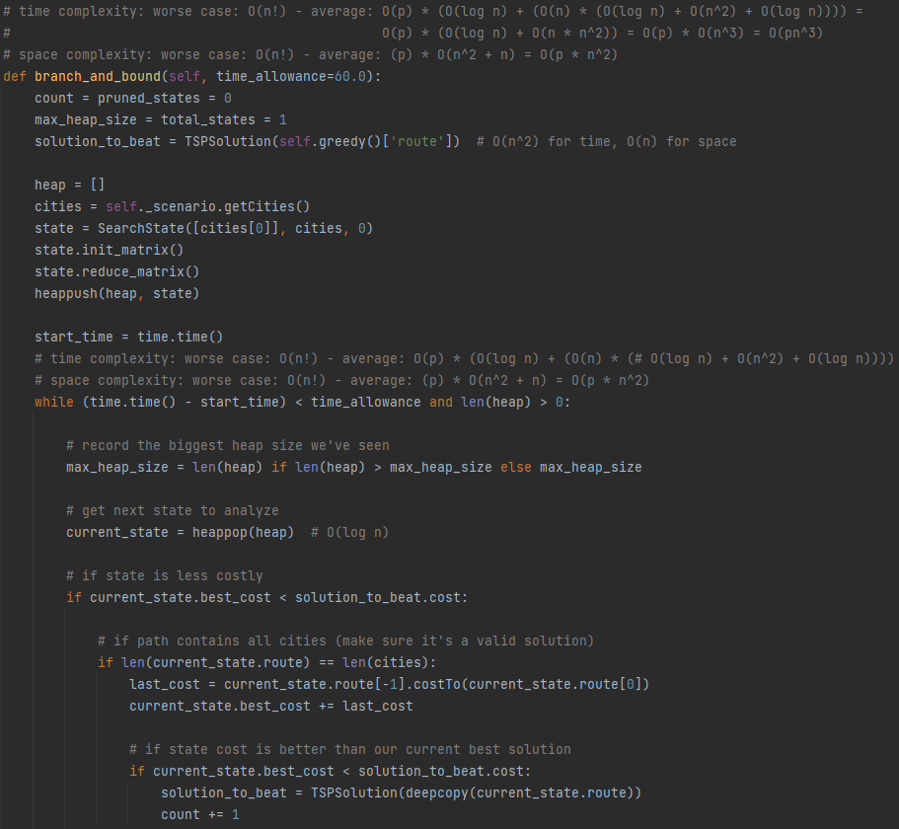
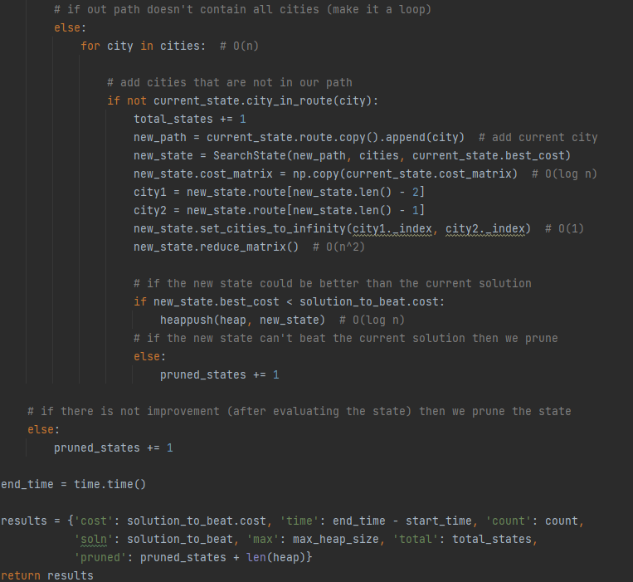
As discussed above, the branch and bound algorithm takes a given path (here generated by the greedy algorithm), and then we expand the search state into deeper levels by looking for possible better decisions and then exploring them in their own state (as previously talked about). Because of the nature of the algorithm, our worst-case scenario will be of order O(n!) for both space and time complexity. However, the average case can be generalized the O(n/k ∑n^i) | p = number of states generated minus the pruned states, and where the sigma goes from i = 1 to p, and where k represents the algorithm’s optimization. This is because, while there are n cities at each depth, we consistently narrow down our search through setting our cost matrix to infinity where possible to speed up computation. We will discuss this p value more in the coming section of the paper.
Empirical Analysis
In this section of the paper we will cover the 6th and 7th portions of the report ([25] Include a table containing the following columns, [10] Discuss the results in the table and why you think the numbers are what they are, including how time complexity and pruned states vary with problem size.)
First, we show our empirical data:
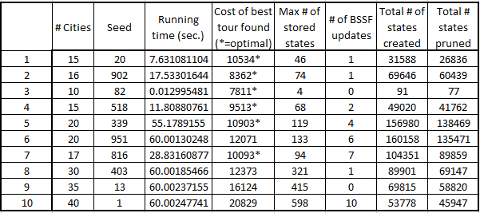
We can see four cases in which no optimal solution was found because of a 60 second time requirement (see case 6, 8, 9, and 10).
Because depth is prioritizing exploration of cheaper possible solutions, the state space doesn’t start to increase rapidly until the number of cities begins to climb (and once done so, the states created start to climb sharply). However, space complexity is held low by focusing on pruning a lot of states early one – meaning the number of max stored states remains very low even when the number of states blows up. Thus, we can see how the total number of states created and pruned are heavily correlated with the problem size. However, the number of BSSF updates depends more on the accuracy of our initial greedy route and how well is does to get to an optimal route. The final observation is that sometimes there are no updates to the BSSF if the greedy approximation is the best is can find within the time frame.
General Discussion
For the general discussion points, sections 3-5 as well as section 8 of the paper requirements (3. [5] Describe the data structures you use to represent the states. 4. [5] Describe the priority queue data structure you use and how it works. 5. [5] Describe your approach for the initial BSSF. 8. [10] Discuss the mechanisms you tried and how effective they were in getting the state space search to dig deeper and find more solutions early.) see the previous discussion (these points were interwoven into the other sections, but all the content is there).
Conclusion
In conclusion, we have shown that our algorithm is correctly running a brand and bound implementation in order to solve the traveling salesperson problem. Much care must be taken to expand search state to deeper levels earlier if gains are to be had in time and space complexity. Thus, we can conclude that the analysis of this branch and bound algorithm stating its completeness and compliance.
Appendix
This portion of the paper covers the first part of the report ([20] Include your well-commented code.)

